AI ASSISTED CODING LAB

ASSIGNMENT 3.2

ENROLLMENT NO :2503A51L33 BATCH NO: 20

NAME: Thirumalakonda Shiva

TASK DESCRIPTION 1: Ask AI to write a function to calculate compound interest, starting with only the function name. Then add a docstring, then input-output example

PROMPT 1: generate a function to calculate compound interest, starting with only the function name. then add a docstring, with principal=1000, rate=5% (0.05), compounded quarterly (4), for 3 years

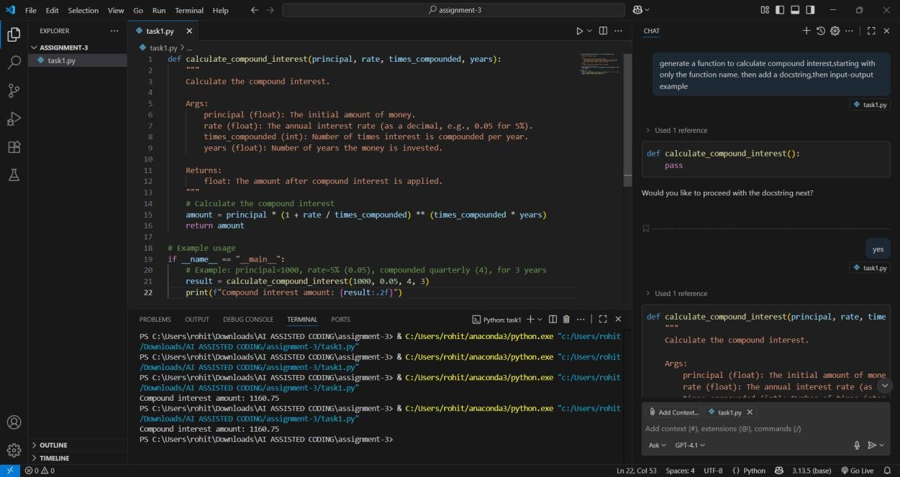

TASK DESCRIPTION 2: Do math stuff, then refine it to: # Write a function to calculate average, median, and mode of a list of numbers.

PROMPT 1: Generate a python function to calculate average, median, and mode of a list of given numbers that are 1,2,2,3,4.

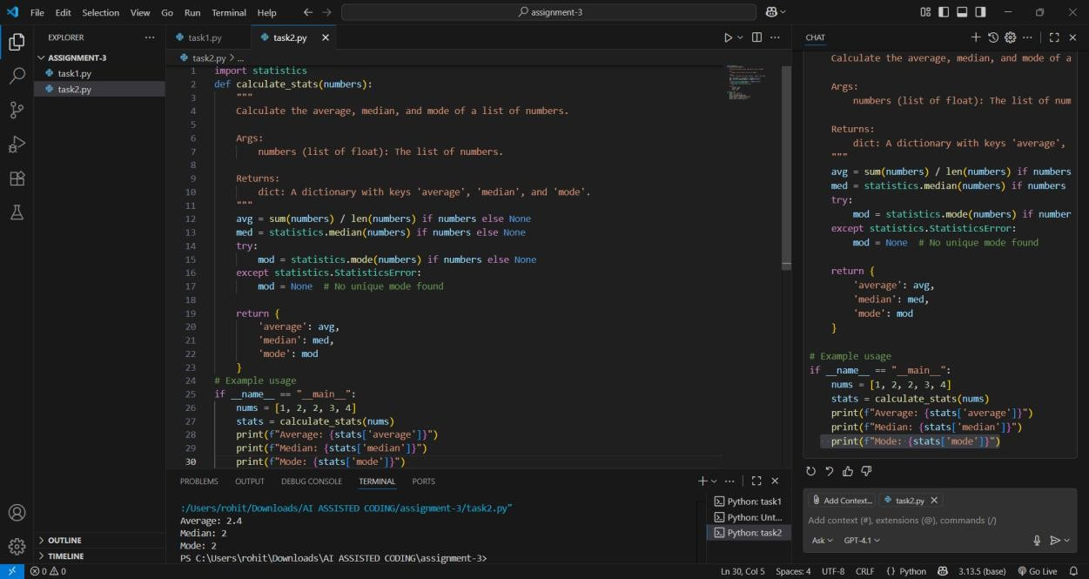

TASK DESCRIPTION 3: Provide multiple examples of input-output to the AI for convert_to_binary(num) function. Observe how AI uses few- shot prompting to generalize.

PROMPT 1: generate python code to Provide multiple examples of input-output to the AI for converting into binary(number) function

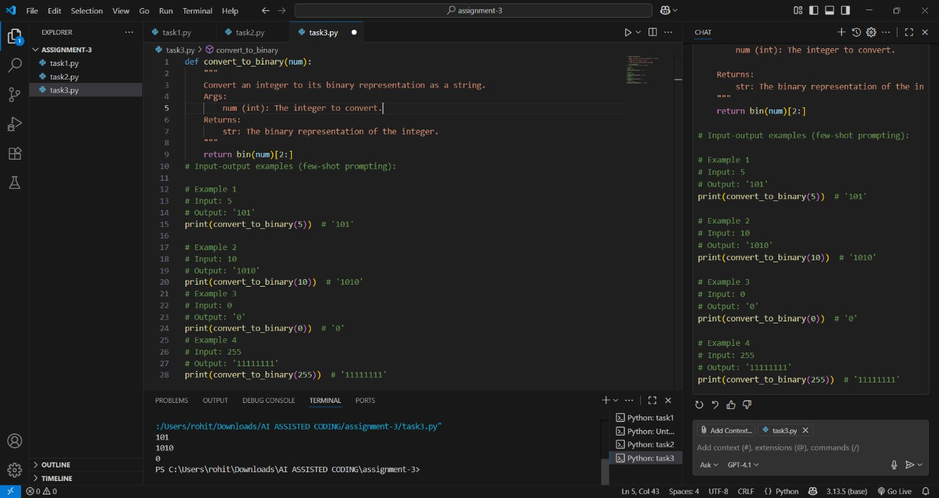

TASK DESCRIPTION 4: Create a user interface for a hotel to generate bill based on customer requirements

PROMPT 1: generate a python code to create a user interface for a hotel to generate bill based on customer requirements

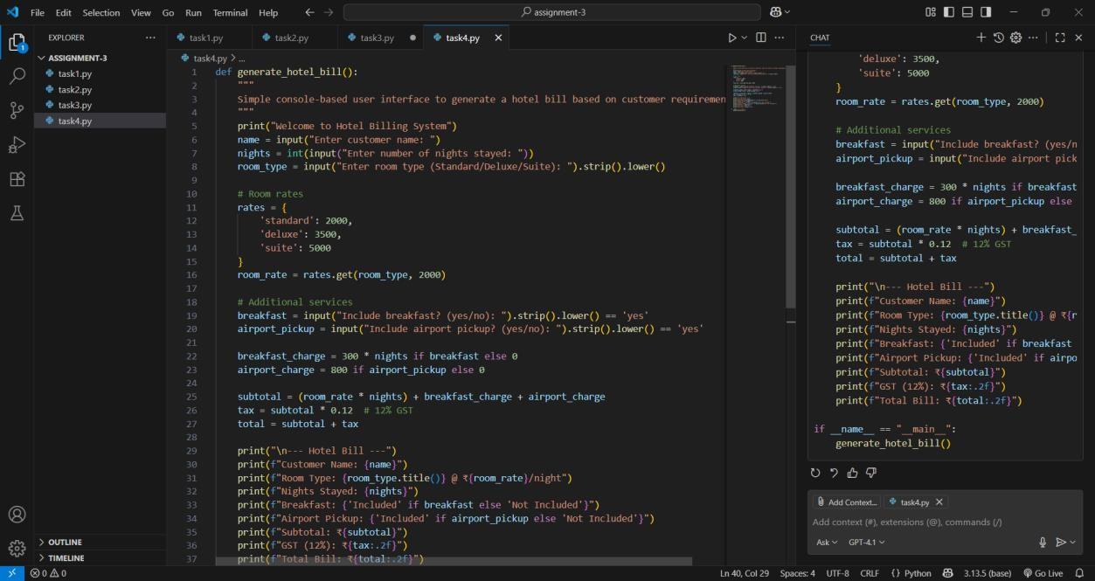

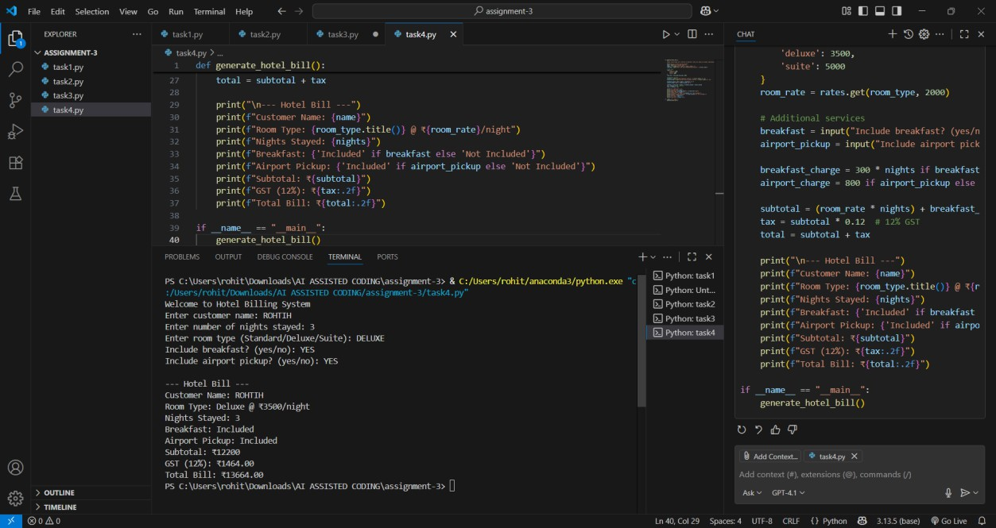

TASK DESCRIPTION 5: Analyzing Prompt Specificity: Improving Temperature Conversion Function with Clear Instructions

PROMPT 1: Write a Python function that converts temperatures between Celsius and Fahrenheit. Accept two arguments: the temperature value and a string indicating the scale ('C' or 'F') Convert the temperature to the opposite scale (Celsius ↔ Fahrenheit)

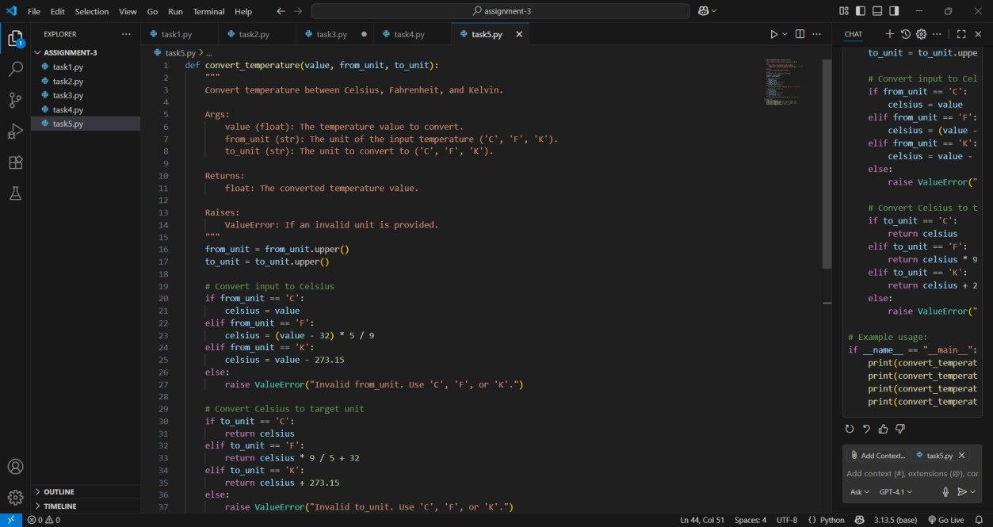

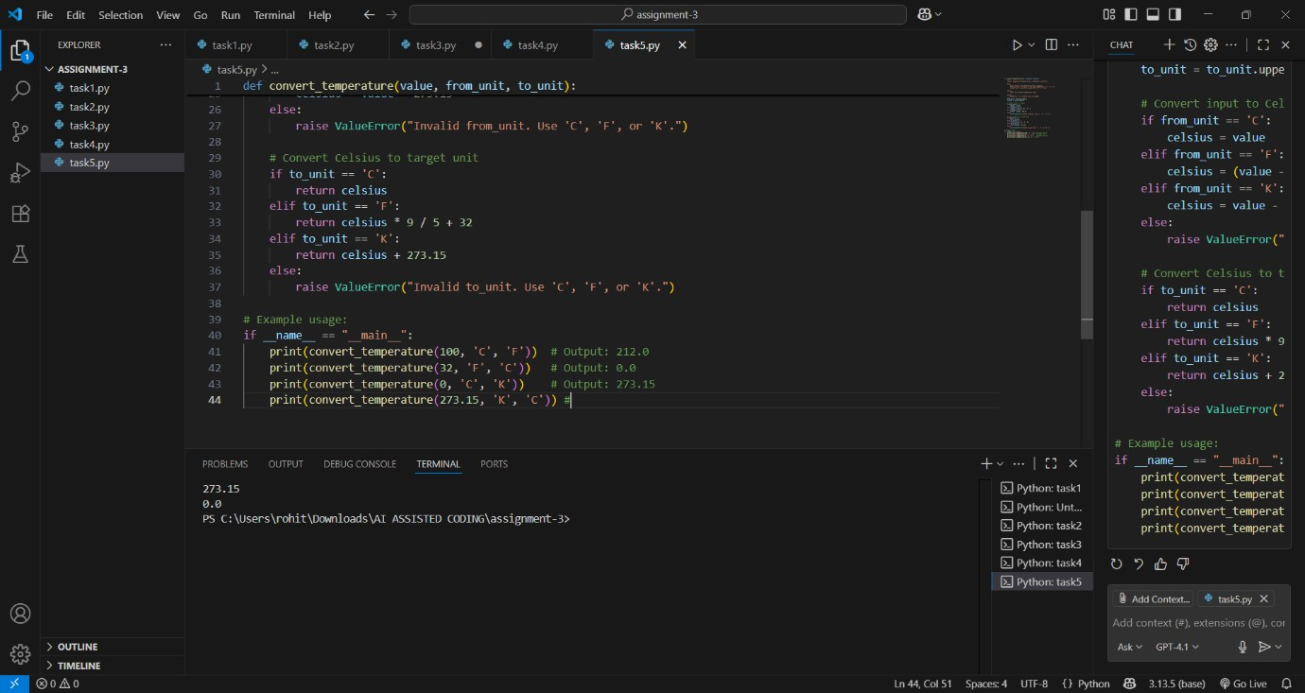

OBSERVATION: The assignment effectively demonstrates how AI can assist in writing Python functions and solving problems through prompt design. It progresses from simple to complex tasks, showcasing prompt refinement and AI generalization. However, adding clearer evaluation criteria, expected outcomes, and slightly more specific instructions would make it more educational and robust.